Teacher: Mrs. Kamuche
Subject: Language Arts, Math, Science, Social studies, Life/Social skills.

Lesson Plan for Week of November 30th, 2015 (week 18)
(Due to GAA our lessons will remain on these concepts till the end of semester. Our ELA will be based on our unique lessons.)

Monday | Tuesday | Wednesday | Thursday | Friday
November 30, 2015 | December 1, 2015 | December 2, 2015 | December 3, 2015 | December 4, 2015
1st Period Study Skills
Morning work- Calendar  Circle time  Starfall, Weather, Interactive calendar  Calendar worksheet | Morning work- Calendar  Circle time  Starfall, Weather, Interactive calendar  Calendar worksheet | Morning work- Calendar  Circle time  Starfall, Weather, Interactive calendar  Calendar worksheet. | Morning work- Calendar  Circle time  Starfall, Weather, Interactive calendar  Calendar worksheet | Morning work- Calendar  Circle time  Starfall, Weather, Interactive calendar  Calendar worksheet
Grade: Progress monitoring sheet | Grade: Reading Entry | Grade: Interactive card | Grade: Reading Entry | Grade: Progress monitoring sheet
Language Arts/Reading
GSE Assessment Limits/Standards: (What are the skills being taught? Which standards are being specifically addressed in this lesson?)

ELAGSE6.RI.2 Determine a central idea of a text and how it is conveyed through particular details; provide a summary of the text distinct from personal opinions or judgments.

Book Reports/Topic Paragraphs

Lesson Objective/Learning Intention: (What will my students KNOW by the end of the lesson? What will they DO to learn it?)

Know: Students will explore various traditions celebrated by families. The traditions are not necessarily tied to traditional winter holiday traditions, but may be applied to a variety of reasons for celebration.

Do: Students will identify traditions done in their families or classrooms, either during the holiday season or throughout the entire year.

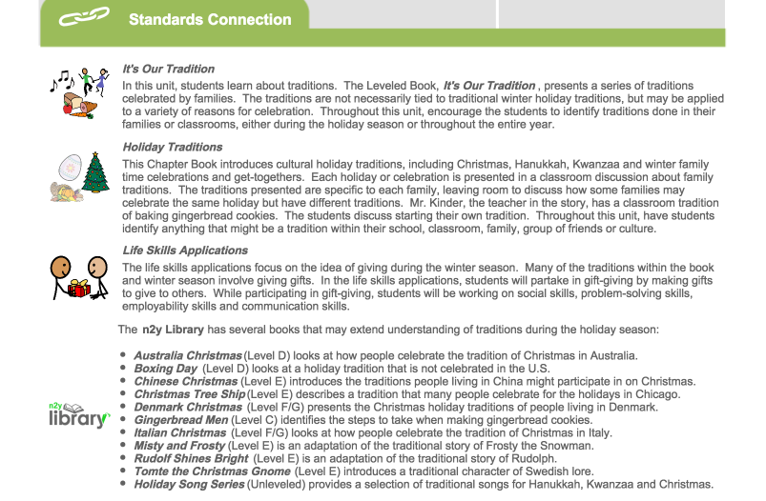

GSE Assessment Limits/Standards: (What are the skills being taught? Which standards are being specifically addressed in this lesson?)

ELAGSE6.SL.1 Review the key ideas expressed and demonstrate understanding of multiple perspectives through reflection and paraphrasing.
Lesson Objective/Learning Intention: (What will my students KNOW by the end of the lesson? What will they DO to learn it?)

Know:
After reading It’s Our Tradition students will : (1)Independently answer questions about the chapter
(2)Answer questions about the chapter by selecting a picture.
Do:
- Use the topic words, and high frequency vocabulary words in conversation about the chapter.
- Students will locate the words in the chapter
Model, Print, and use picture support to create Book Report/Topic Paragraph using skills and strategies.

Mathematics
MGSE6.RP.1. Understand the concept of a ratio and use ratio language to describe a ratio relationship between two quantities. For example, “The ratio of wings to beaks in the bird house at the zoo was 2:1, because for every 2 wings there was 1 beak.” “For every vote candidate A received, candidate C received nearly three votes.”

Know: A ratio is how many times bigger one thing is than another. It's a number you multiply by to get one thing from another.
But remember, when you find the ratio of two quantities, they must be in the same units.
A ratio compares values.
That ratio is relationship between two measures, expressed as the number of times one is bigger or smaller than the other.
Ratios are usually written as two numbers separated by a colon.
Ratios can also be written as a fraction, where the top (numerator), and the bottom (denominator)

DO: Students will compare values to understand ratios

Students will compare 3 blue squares to 1 yellow square
Students will compare 6 yellow squares to 3 blue squares
Students will demonstrate different ways to write ratios.

MGSE8.G.2 Understand that a two-dimensional figure is congruent to another if the second can be obtained from the first by a sequence of rotations, reflections, and translations; given two congruent figures, describe a sequence that exhibits the congruence between them.

Know: Geometric figures are congruent if they have the same shape and the same size. If you place one figure on top of the other and they fit exactly, they are congruent.
Corresponding angles of congruent figures are equal, and the corresponding side are equal.
Corresponding means “in the same position.”

DO: Explain congruent and incongruent in your own words
Find objects that are congruent in the classroom, Gym, computer lab, and around the school.
Identify congruent and incongruent figures by placing them in the correct column.

Note: Some math concepts are based on students’ IEP goals.

Science
GSE Assessment Limits/Standards: (What are the skills being taught? Which standards are being specifically addressed in this lesson?)

S6E6. Students will describe various sources of energy, their uses and conservation
- Explain the role of the sun as the major source of energy and its relationship to wind and water energy.
- Identify renewable and nonrenewable resources.

Know: Describe various sources of energy and with their uses and conservation
Explain the role of the sun as the major source of energy and its relationship to wind and water energy
Identify renewable and nonrenewable resources.

DO:
Identify different types of energy
Cut and paste picture-supported resources into the category that they belong.

S8P3: Students will investigate relationship between force, mass, and the motion of objects.
- Demonstrate the effect of simple machines (lever, inclined plane, pulley, wedge, screw, and wheel and axle) on work

Know: Students will know relationship between force, mass, and the motion of objects.
Know the use of simple machines.

Do: Name and identify simple machines.
Match simple machine to its operations.

NOTE: Our lessons are 20-30 minutes long to give us time to transition and expose our students to all their academic and life/social skill areas.

Social Studies
GSE Assessment Limits/Standards: (What are the skills being taught? Which standards are being specifically addressed in this lesson?)  SS8G1: The student will describe Georgia with regard to physical features and location.  - Locate Georgia in relation to region, nation, continent, and hemispheres.  SS6GS: The Student will locate selected features of Canada.  - Locate on a world and regional political-physical map: The St. Lawrence River, Hudson Bay, Atlantic Ocean, Pacific Ocean, The Great Lakes, Canadian Shield, and Rocky Mountains |  | What will my students KNOW by the end of the lesson? What will they DO to learn it?)  SS8G1: Know – Physical features and location of Georgia.  DO – Identify on a map Georgia features in relation to region, nation, continent, and hemisphere.  SS6GS: Know: Students will know selected features of Canada.  DO: Given a map, identify the St. Lawrence River, Hudson Bay, Atlantic Ocean, Pacific Ocean, the Great Lakes, Canadian Shield, and Rocky Mountains.
Instructional Sequence
Picture walk – Introduction of concept, use of adapted text | Engage /Motivation- student will be drawn to concepts by using connections in students’ experiential background. | whole Group instruction  using active board, multimedia, the whole class will engage in discussion of our concept | Small Group Instruction- Student will engage in models, graphic organizer and demonstrations and at times use iPad to enhance understanding | -Independent Practice  Students will work on practice worksheet to demonstrate mastery.
Instructional Sequence
Evaluate/Assessment  Progress monitoring worksheet, assessment data in students folder | Closing Activities/Summary/DLIQ  Group Review and marginal notes | Enhancement /Extension/Re-teaching/Accommodation  Differentiation is consistently practiced based on content, process, and product and learning profile of my students. | Resources  Unique Curriculum and other instructional materials that tailor to my students’ need. | -Picture symbols, objects and realia, visuals to help students retain concepts.
Notes
We incorporate life skills, game activities, fine and gross motor skills as well as WICOR, WELLNESS AND WIGGLES to help our students maintain their needs. Our students also have Leisure Activity Time that help them with their social skill needs. | We incorporate life skills, game activities, fine and gross motor skills as well as WICOR, WELLNESS AND WIGGLES to help our students maintain their needs. Our students also have Leisure Activity Time that help them with their social skill needs. | We incorporate life skills, game activities, fine and gross motor skills as well as WICOR, WELLNESS AND WIGGLES to help our students maintain their needs. Our students also have Leisure Activity Time that help them with their social skill needs. | We incorporate life skills, game activities, fine and gross motor skills as well as WICOR, WELLNESS AND WIGGLES to help our students maintain their needs. Our students also have Leisure Activity Time that help them with their social skill needs. | We incorporate life skills, game activities, fine and gross motor skills as well as WICOR, WELLNESS AND WIGGLES to help our students maintain their needs. Our students also have Leisure Activity Time that help them with their social skill needs.
Structure | Instructional Strategies Used- Please highlight, bold, or underline
Whole Group | -Anticipatory guides/sets -Book/author talks -Cornell Notes  -Close Reading -Questioning the Author (QtA) -Question-Answer-Relationships (QAR)  -Text annotation -Think aloud -Think/Pair/Share
Guided Practice/Small group | -Anticipatory guides/sets -Book/author talks -Cornell Notes  -Close Reading -Literature Circles -Questioning the Author (QtA)  -Question-Answer-Relationships (QAR) -Reading conferences -Reciprocal teaching  -Strategy groups -Text annotation -Think aloud  -Think/Pair/Share -Writing Conferences
Independent Practice | -Anticipatory guides/sets -Book/author talks -Cornell Notes  -Close Reading -Literature Circles -Questioning the Author (QtA)  -Question-Answer-Relationships (QAR) -Reading conferences -Reciprocal teaching  -Strategy groups -Text annotation -Think aloud  -Think/Pair/Share -Writing Conferences

NOTE: Most of my students can only respond to these instructional Strategies using full physical guidance, model, prompt and partial physical guidance.

Due to the importance of concepts covered in this lesson, my students will continue to learn different regions and landforms as part of their social Studies lesson.
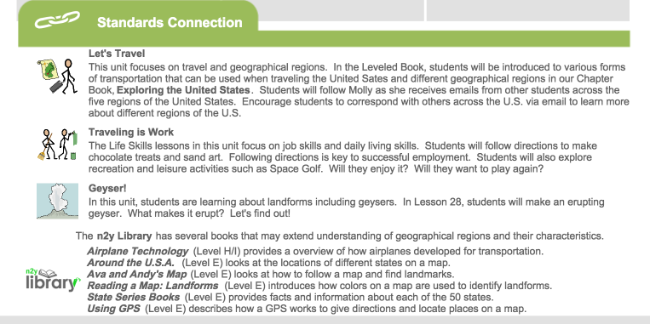
Do:
Identify different regions in US
Describe transportation methods used in US

Lesson Objective/Learning Intention: (What will my students KNOW by the end of the lesson? What will they DO to learn it?)

Know: Know: Students will explore various forms of transportation that can be used when traveling the United States and different geographical regions through leveled reading.

